1) Jacoco Report
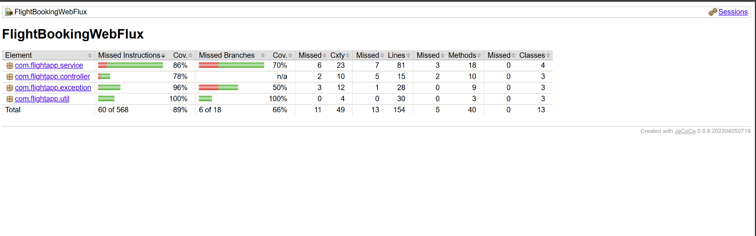
2) SonarCube Report
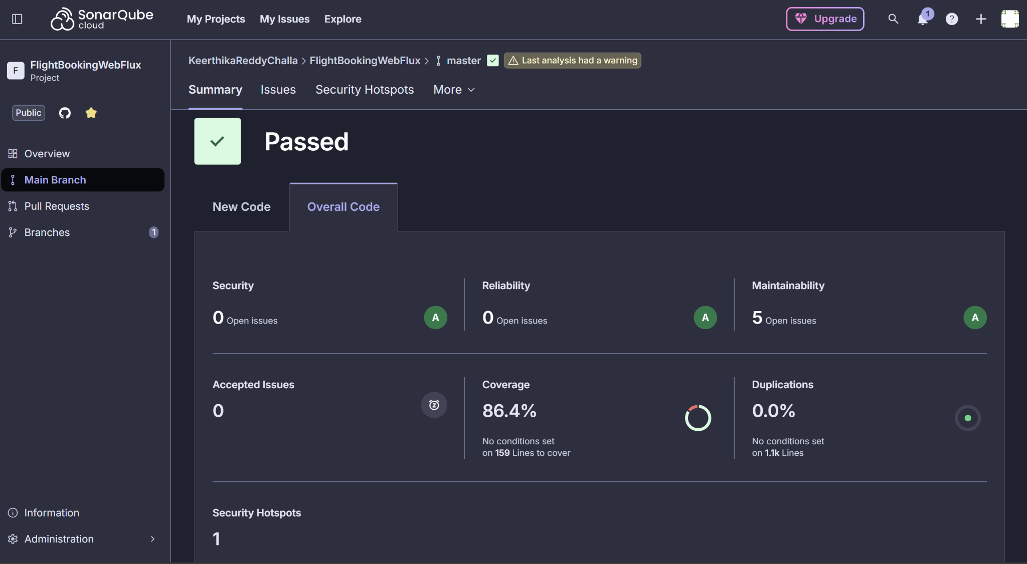
3)Jmeter result-tree
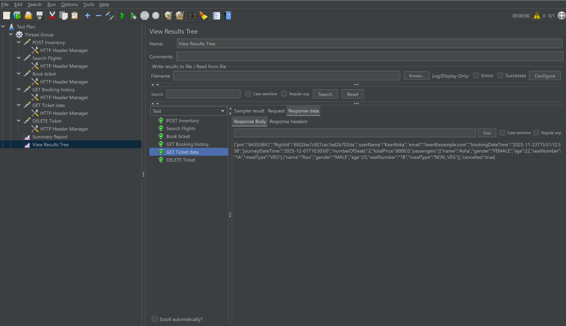
4) Jmeter Summary-report (1-sample)

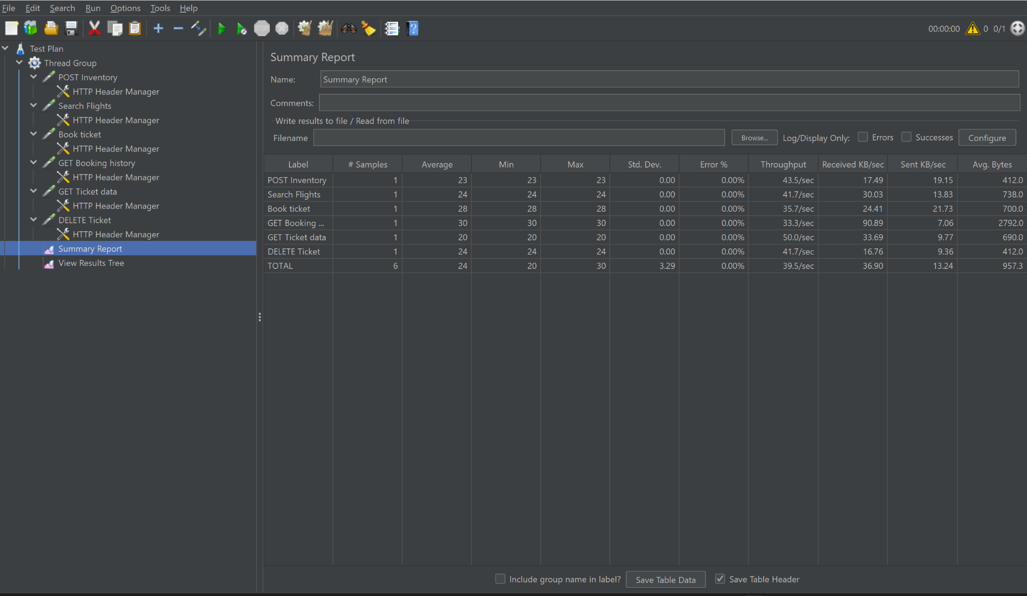

5) Jmeter Summary-report (20-samples)

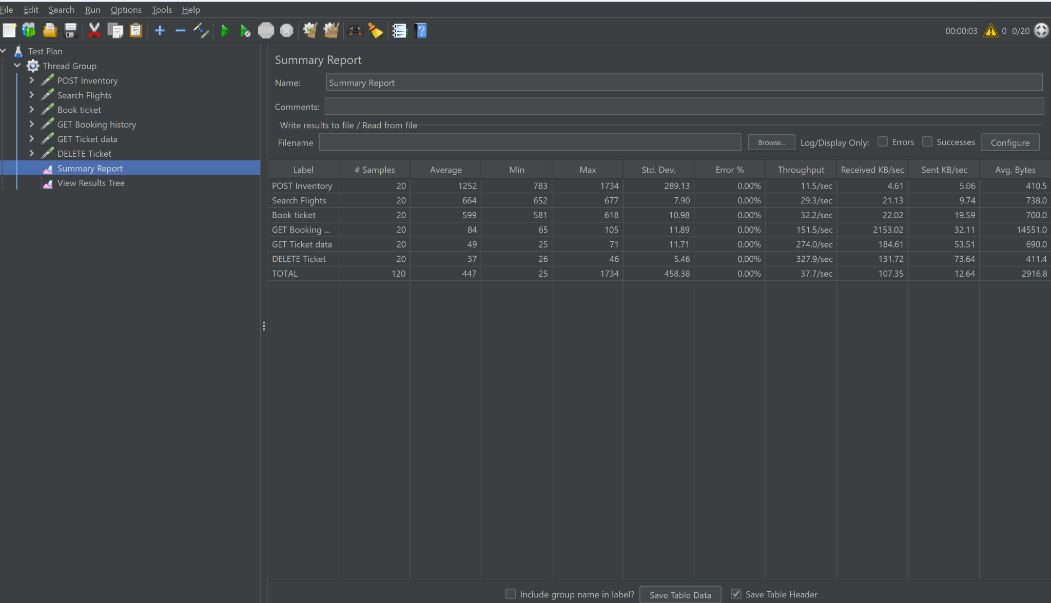

6) Jmeter Summary-report (40-samples)

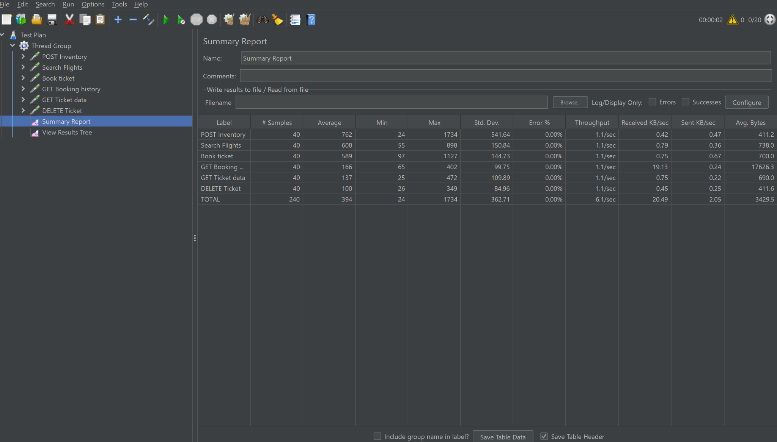

7) Jmeter Summary-report (100-samples)

